**Program 1.**

**Program Name:** Copy array in reverse

**Program Purpose:** Using array

**Problem Statement:** Write a program to copy the contents of one array into another in the reverse order.

Steps:

Declare another array of same size

Copy last element of arr1 in first element of arr2, second last of arr1 into second of arr2 and so on…

arr2[0] = arr[4]

arr2[1] = arr[3]

arr2[2] = arr[2]

arr2[3] = arr[1]

arr2[4] = arr[0]

**Sample Output:**

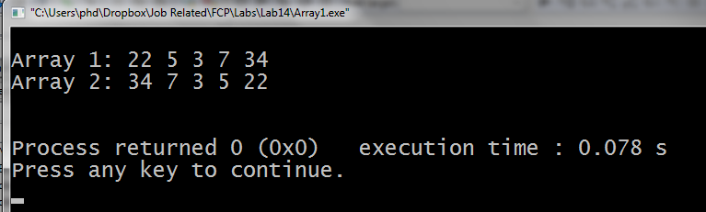

**Program 2.**

**Program Name:** Array Palindrome

**Program Purpose:** Using array

**Problem Statement:** If an array **arr** contains **n** elements, then write a program to check if the array is a palindrome. i.e. **arr[0] = arr[n-1]**, **arr[1] = arr[n-2]** and so on.

For example an array {5, 8, 0, -1, 0, 8, 5} is a palindrome, but {3, 4, 9, 1, 9, 5, 3} is not.

**Program 3.**

**Program Name:** Searching an array

**Program Purpose:** Passing array to function

**Problem Statement:** An array is initialized with twenty-five numbers. Then, a number is entered through the keyboard by the user, which should be searched in the array. Write a function to print whether the number to be searched is present in the array or not, and if it is present, display the number of times it appears in the array.

**Sample Outputs:**

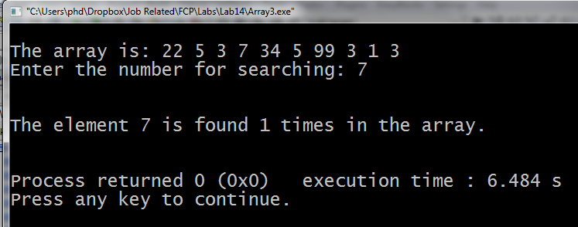

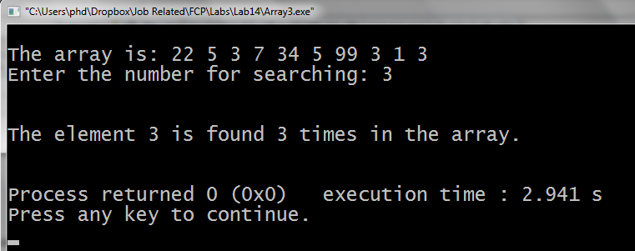

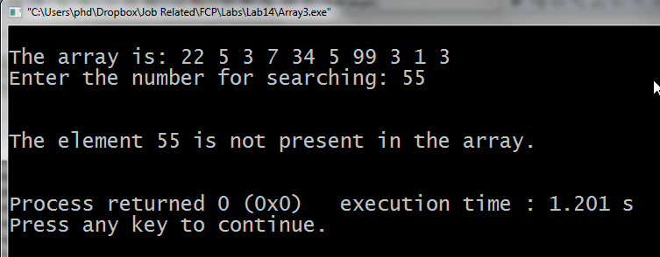

**Program 4.**

Complete the above program using binary search.

**Program 5.**

**Program Name:** 2D array declaration and outputusing nested for loops

**Program Purpose:** using 2D arrays

**Problem Statement:** Write a program which declares a 2D array of size 4x4 with following values.

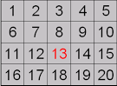

Complete the following tasks.

* Print the values in each row of a 2D array using single for loop.
* Print each value in 2D array using nested for loop.